

**A SKILL BASED EVALUATION REPORT**

**SUBMITTED BY**

**ANSON SAJU GEORGE (URK2CS7064)**

**COURSE CODE 20CS2035**

**COURSE NAME**

**OBJECT ORIENTED PROGRAMMING**

**OCTOBER 2023**



**DIVISION OF COMPUTER SCIENCE AND ENGINEERING SCHOOL OF ENGINEERING AND TECHNOLOGY**

**INDUSTRIAL CERTIFICATION**

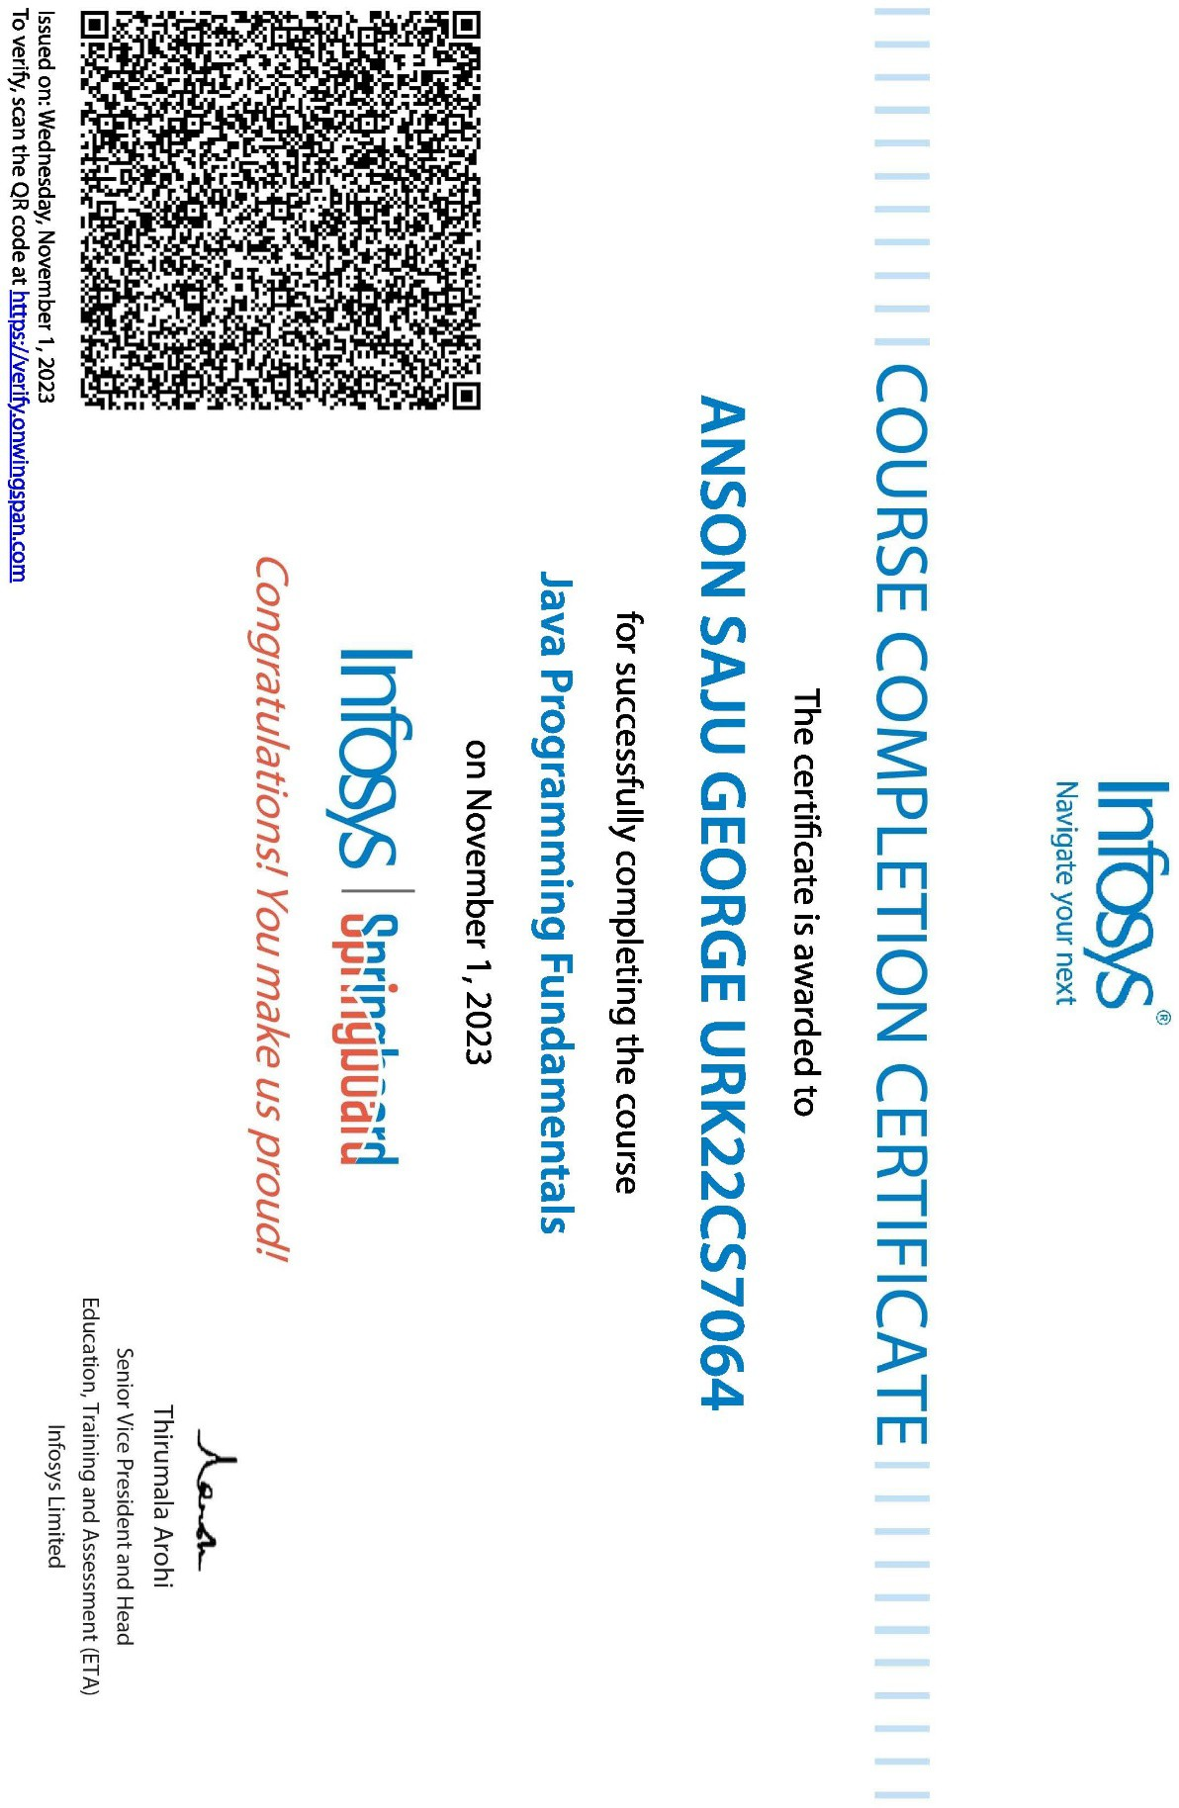

**TITLE**

Map Application

***A REAL TIME APPLICATION REPORT***

***Submitted by***

**Anson Saju George URK22CS7064**

**Elias John Sabu URK22CS2024**



**DIVISION OF COMPUTER SCIENCE AND ENGINEERING**

**KARUNYA INSTITUTE OF TECHNOLOGY AND SCIENCES**

# (Declared as Deemed-to-be-under Sec-3 of the UGC Act, 1956) Karunya Nagar, Coimbatore - 641 114. INDIA

**OCTOBER 2023**

## ABSTRACT

Our updated Maps Application represents a cutting-edge solution in the realm of travel and navigation. With an emphasis on providing an intuitive and user-friendly travel companion, this application leverages Mapbox's powerful mapping services to offer an all-encompassing solution for efficient journey planning. Users can seamlessly visualize routes on interactive maps, harness real-time location services, and navigate with ease. By simplifying route planning and map interaction, this application offers a streamlined and enjoyable travel experience. As a versatile travel companion, it addresses the complexities of modern journey planning and remains committed to enhancing the user's travel journey, making it accessible to individuals with various technical backgrounds. In a world where convenience and efficiency are paramount, our updated Maps Application stands as a testament to modern travel innovation.

## PROBLEM STATEMENT

In today's dynamic and interconnected world, travelers frequently encounter the challenge of efficiently planning their journeys, especially when navigating unfamiliar destinations or seeking to optimize routes for cost-effectiveness and timeliness. While conventional navigation and mapping applications have proven useful, they often fall short of offering a holistic solution. Users are left in search of a comprehensive travel companion that seamlessly combines intuitive map visualization, real-time location services, and user-friendly route planning. This deficiency underscores the need for an all-encompassing travel application that simplifies the complexities of modern travel. Our Maps Application is a response to this pressing problem. It aims to provide a solution that not only streamlines journey planning but also simplifies route visualization, ensuring a seamless and enjoyable travel experience. In a world where efficient travel management is paramount, our application strives to become the ultimate solution, revolutionizing how users plan their journeys and navigate through today's ever-evolving landscape.

## METHODOLOGY / ARCHITECTURE

In our project, we've meticulously crafted a Map-Based Android Application, skillfully harnessing Mapbox's mapping services to provide users with a seamless and user-friendly travel companion. The central goal of this application is to empower users in planning their journeys, enabling them to visualize routes on an interactive map and ensuring that each travel experience is both hassle-free and enjoyable.

Our methodology revolves around the core components and underlying logic that constitute the application's functionality:

First and foremost, our Mapbox integration forms the backbone of this digital travel tool, serving as the virtual canvas for maps and offering cutting-edge navigation capabilities. This allows users to explore and navigate with ease, just like having a personal GPS at their fingertips.

Furthermore, our implementation of location services enables users to pinpoint their current position on the map, providing valuable context and ensuring they're always oriented. It's akin to having a digital compass, aiding users on their journeys.

Our user interface (UI) design plays a pivotal role by simplifying the process of entering journey details and interacting with the map. We've placed a strong emphasis on making the application accessible to users with diverse technical backgrounds, ensuring that it's intuitive and user-friendly.

Lastly, the application's permission handling mechanism takes care of securing the user's consent to access their device's location information. This not only enhances privacy but also guarantees a seamless user experience.

In conclusion, this methodology statement encapsulates our unwavering commitment to providing a smooth and intuitive travel planning experience. We're dedicated to delivering a digital travel companion that makes journey planning accessible and enjoyable to users from all walks of life.

## IMPLEMENTATION – CODING AND OUTPUT SCREENSHOT

package com.example.mapbox;

import static com.mapbox.maps.plugin.gestures.GesturesUtils.getGestures; import

static.com.mapbox.maps.plugin.locationcomponent.LocationComponentUtils.getLocationCo mponent;

import android.Manifest;

import android.content.pm.PackageManager; import android.os.Bundle;

import android.view.View; import android.widget.Toast;

import androidx.activity.result.ActivityResultCallback; import androidx.activity.result.ActivityResultLauncher;

import androidx.activity.result.contract.ActivityResultContracts; import androidx.annotation.NonNull;

import androidx.appcompat.app.AppCompatActivity;

import androidx.appcompat.content.res.AppCompatResources; import androidx.core.app.ActivityCompat;

import com.google.android.material.floatingactionbutton.FloatingActionButton; import com.mapbox.android.gestures.MoveGestureDetector;

import com.mapbox.geojson.Point;

import com.mapbox.maps.CameraOptions; import com.mapbox.maps.MapView; import com.mapbox.maps.Style;

import com.mapbox.maps.plugin.LocationPuck2D;

import com.mapbox.maps.plugin.gestures.OnMoveListener;

import com.mapbox.maps.plugin.locationcomponent.LocationComponentPlugin;

import com.mapbox.maps.plugin.locationcomponent.OnIndicatorBearingChangedListener;

import com.mapbox.maps.plugin.locationcomponent.OnIndicatorPositionChangedListener;

public class MainActivity extends AppCompatActivity { private MapView mapView;

FloatingActionButton floatingActionButton;

private final ActivityResultLauncher<String> activityResultLauncher = registerForActivityResult(new ActivityResultContracts.RequestPermission(), new ActivityResultCallback<Boolean>() {

@Override

public void onActivityResult(Boolean result) { if (result) {

Toast.makeText(MainActivity.this, "Permission granted!", Toast.LENGTH_SHORT).show();

}

}

});

private final OnIndicatorBearingChangedListener onIndicatorBearingChangedListener

= new OnIndicatorBearingChangedListener() { @Override

public void onIndicatorBearingChanged(double v) {

mapView.getMapboxMap().setCamera(new CameraOptions.Builder().bearing(v).build());

}

};

private final OnIndicatorPositionChangedListener onIndicatorPositionChangedListener

= new OnIndicatorPositionChangedListener() {

@Override

public void onIndicatorPositionChanged(@NonNull Point point) { mapView.getMapboxMap().setCamera(new

CameraOptions.Builder().center(point).zoom(20.0).build());

getGestures(mapView).setFocalPoint(mapView.getMapboxMap().pixelForCoordinate(point))

;

}

};

private final OnMoveListener onMoveListener = new OnMoveListener() { @Override

public void onMoveBegin(@NonNull MoveGestureDetector moveGestureDetector)

{

getLocationComponent(mapView).removeOnIndicatorBearingChangedListener(onIndicatorB earingChangedListener);

getLocationComponent(mapView).removeOnIndicatorPositionChangedListener(onIndicatorP ositionChangedListener);

getGestures(mapView).removeOnMoveListener(onMoveListener); floatingActionButton.show();

}

@Override

public boolean onMove(@NonNull MoveGestureDetector moveGestureDetector) { return false;

}

@Override

public void onMoveEnd(@NonNull MoveGestureDetector moveGestureDetector) {

}

};

@Override

protected void onCreate(Bundle savedInstanceState) { super.onCreate(savedInstanceState); setContentView(R.layout.activity_main);

mapView = findViewById(R.id.mapView); floatingActionButton = findViewById(R.id.focusLocation);

if (ActivityCompat.checkSelfPermission(MainActivity.this, Manifest.permission.ACCESS_FINE_LOCATION) != PackageManager.PERMISSION_GRANTED) {

activityResultLauncher.launch(Manifest.permission.ACCESS_FINE_LOCATION);

}

floatingActionButton.hide(); mapView.getMapboxMap().loadStyleUri(Style.SATELLITE, new

Style.OnStyleLoaded() {

@Override

public void onStyleLoaded(@NonNull Style style) { mapView.getMapboxMap().setCamera(new

CameraOptions.Builder().zoom(20.0).build());

LocationComponentPlugin locationComponentPlugin = getLocationComponent(mapView);

locationComponentPlugin.setEnabled(true); LocationPuck2D locationPuck2D = new LocationPuck2D();

locationPuck2D.setBearingImage(AppCompatResources.getDrawable(MainActivity.this, R.drawable.baseline_location_on_24));

locationComponentPlugin.setLocationPuck(locationPuck2D);

locationComponentPlugin.addOnIndicatorBearingChangedListener(onIndicatorBearingChan gedListener);

locationComponentPlugin.addOnIndicatorPositionChangedListener(onIndicatorPositionChan gedListener);

getGestures(mapView).addOnMoveListener(onMoveListener);

floatingActionButton.setOnClickListener(new View.OnClickListener() { @Override

public void onClick(View view) {

locationComponentPlugin.addOnIndicatorBearingChangedListener(onIndicatorBearingChan gedListener);

locationComponentPlugin.addOnIndicatorPositionChangedListener(onIndicatorPositionChan gedListener);

}

});

}

}

}

});

getGestures(mapView).addOnMoveListener(onMoveListener); floatingActionButton.hide();

activity_main.xml

<?xml version="1.0" encoding="utf-8"?>

<RelativeLayout xmlns:android="[http://schemas.android.com/apk/res/android"](http://schemas.android.com/apk/res/android) xmlns:app="[http://schemas.android.com/apk/res-auto"](http://schemas.android.com/apk/res-auto) xmlns:tools=["http](http://schemas.android.com/tools):[//schemas.android.com/tools](http://schemas.android.com/tools)" xmlns:mapbox="[http://schemas.android.com/apk/res-auto"](http://schemas.android.com/apk/res-auto) android:layout_width="match_parent" android:layout_height="match_parent"

tools:context=".MainActivity">

<com.mapbox.maps.MapView android:id="@+id/mapView" android:layout_width="match_parent" android:layout_height="match_parent" mapbox:mapbox_cameraTargetLat="-122.295252" mapbox:mapbox_cameraTargetLng="47.477197" mapbox:mapbox_cameraZoom="9.0" />

<com.google.android.material.floatingactionbutton.FloatingActionButton android:id="@+id/focusLocation" android:layout_width="wrap_content" android:layout_height="wrap_content" android:layout_alignParentEnd="true" android:layout_alignParentBottom="true" android:layout_marginStart="16sp" android:layout_marginTop="16sp"

android:layout_marginEnd="16sp" android:layout_marginBottom="16sp" android:src="@drawable/baseline_my_location_24" />

</RelativeLayout> build.graddle plugins {

id 'com.android.application'

}

android {

namespace 'com.example.mapbox'

compileSdk 33

defaultConfig {

applicationId "com.example.mapbox" minSdk 24

targetSdk 33

versionCode 1

versionName "1.0"

testInstrumentationRunner "androidx.test.runner.AndroidJUnitRunner"

}

buildTypes { release {

minifyEnabled false

proguardFiles getDefaultProguardFile('proguard-android-optimize.txt'), 'proguard-

rules.pro'

}

}

compileOptions {

sourceCompatibility JavaVersion.VERSION_1_8 targetCompatibility JavaVersion.VERSION_1_8

}

}

dependencies {

implementation 'androidx.appcompat:appcompat:1.6.1' implementation 'com.google.android.material:material:1.9.0' implementation 'androidx.constraintlayout:constraintlayout:2.1.4' testImplementation 'junit:junit:4.13.2'

androidTestImplementation 'androidx.test.ext:junit:1.1.5' androidTestImplementation 'androidx.test.espresso:espresso-core:3.5.1' implementation 'com.mapbox.maps:android:10.16.1'

}

## OUTPUT

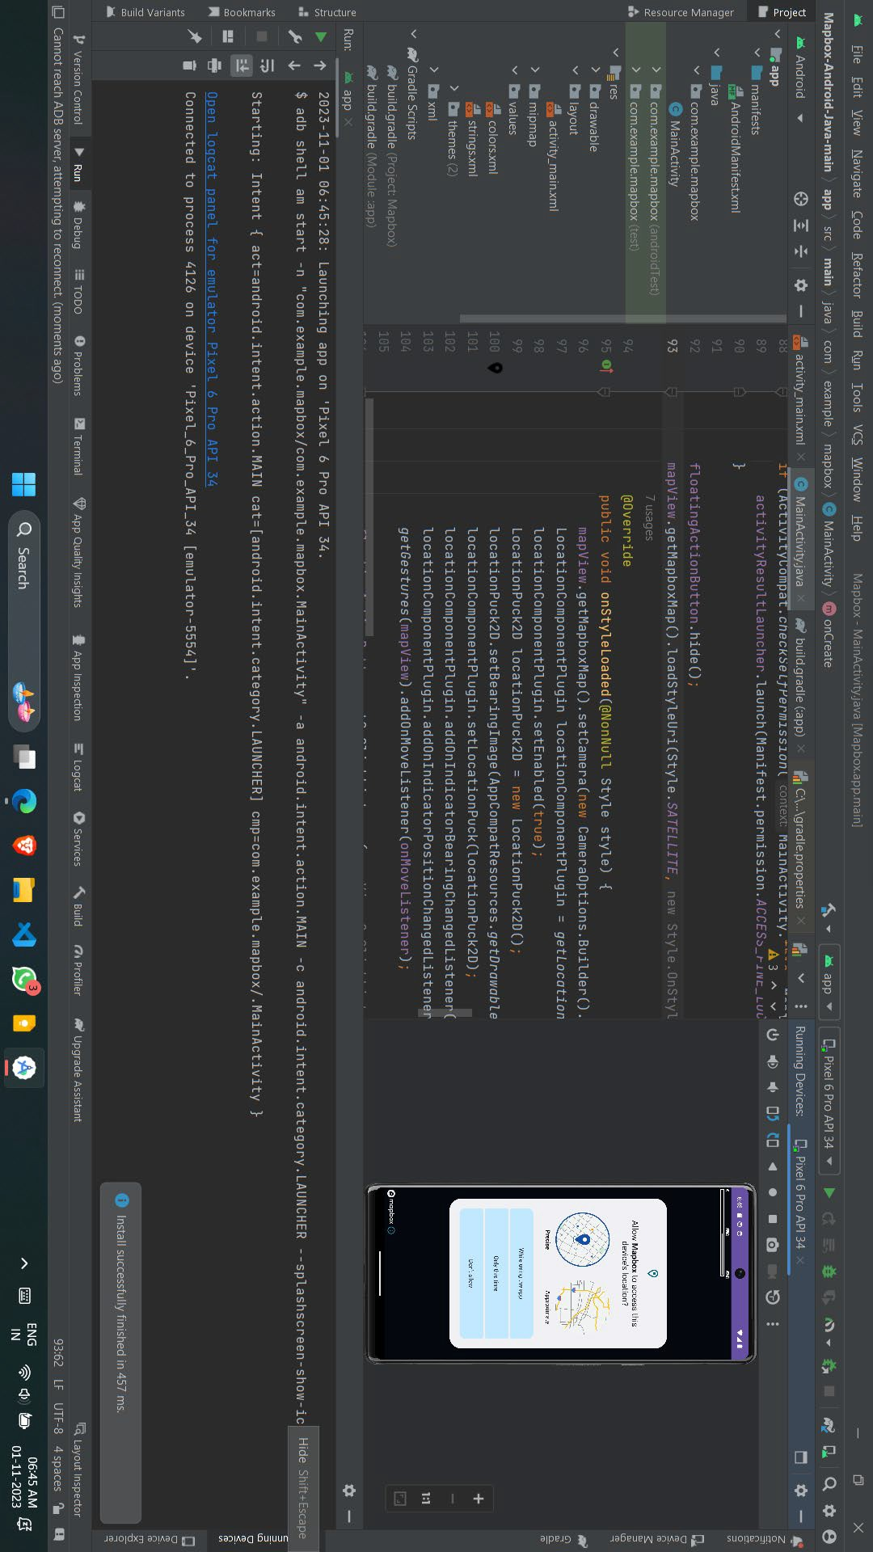

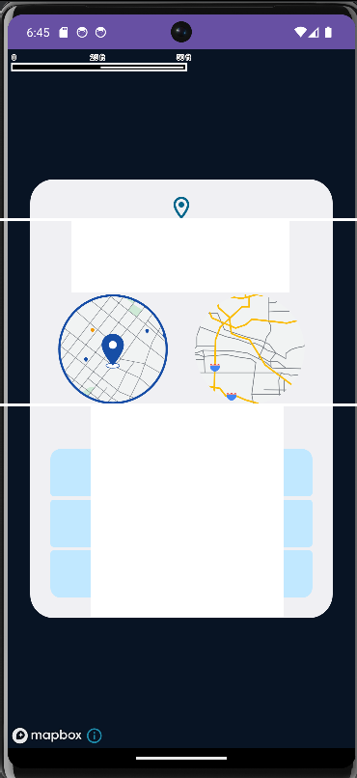

Allow **Mapbox** to access this device's location?

Precise

Approximate

**While using the app**

Only this time

Don't allow

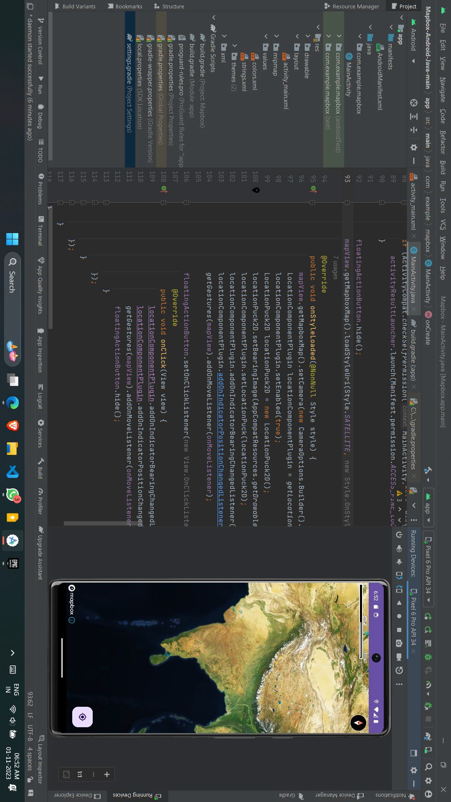

**CONCLUSION**

Our maps application represents a comprehensive solution to the challenges faced by modern travelers. By integrating Mapbox's powerful API, we provide accurate and efficient mapping services, while our gas price calculation feature empowers users to make informed, budget-conscious decisions about their journeys. The user-friendly interface ensures that planning routes is a seamless and enjoyable experience. In a world where time and resources are of the essence, our application simplifies route planning and financial management. Whether for daily commutes or cross-country adventures, we offer a valuable tool that enhances the overall travel experience. Embracing technology and usability, our solution is tailored to meet the evolving needs of today's travelers.

**EVALUATION SHEET**

**Reg.No : URK22CS7064**

**Name: Anson Saju George Course code: 20CS2035**

**Course Name: Object Oriented Programming**

|  |  |  |  |
| --- | --- | --- | --- |
| **S.No** | **Rubrics** | **Maximum Marks** | **Marks Obtained** |
| 1 | Industrial Certification | 10 |  |
| 2 | Real – Time Application Design | 30 |  |
| Total | | 40 |  |

|  |  |  |  |  |
| --- | --- | --- | --- | --- |
| **Rubrics** | **Excellent** | **Good** | **Average** | **Below Average** |
| **Classes and Inheritance** |  |  |  |  |
| **Concept Used** |  |  |  |  |
| **GUI** |  |  |  |  |
| **Database** |  |  |  |  |
| **Innovation** |  |  |  |  |
| **Presentation and Viva** |  |  |  |  |
| **Report** |  |  |  |  |

**Signature of the Faculty-in-charge**